Title: | CLUSTER  SW Component

History
Issue status  (Index) | Maturity/Date  (draft/invalid/valid)  (dd-mmm-yyyy) | Author  Department | Check/Release  Department | Description
1.0 | Draft  11-Dic-09 | Georgina Salazar  Carlos Martinez |  | Creation of the document
2.0 | Draft  12-Dic-09 | Georgina Salazar  Carlos Martinez |  | State Machine for speedometer, fuel gauge and visual indicators have been added.

Table of Contents
1 Purpose 3
2 Definitions and abbreviations 3
3 Realization constraints and targets 3
4 SW Conceptual design 3
5 SW Component internal breakdown 4
5.1 Functional Decomposition 4
5.2 Function <Type> <function name> (type par 1, .., type par n) 5
5.3 Function <Type> <function name> (type par 1, .., type par n) 5

Purpose
This document has been created for the conceptual design of a cluster, the main objective is to explain the customer requirements about the behavior of the module that control the panel of instruments in a car and the solution for this requirements through a software entity implemented into a microcontroller that satisfies all customer requirements.

For this project we use layered programming, this will help us to have a better structure in the code and we can be able to see where we are developing, where this modifications will impact and in the case of error, where is it happening. This project work whit 3 layers, MCAL, HAL and APP.

Definitions and abbreviations
Definitions
S32K144 | Microcontroller Unit
MCAL  HAL | Microcontroller Abstraction layer  Hardware Abstraction layer
APP  LED | Application layer  Light emitting diode
T_ULONG | Unsigned long.
T_UBYTE | Unsigned char
WDOG | Watch Dog
GPIO | General Purpose Input and Output
REG | Register
ADDR | Address
PCC | Peripheral Clock Controller
SCG | System Clock Generator
LPIT | Low Power Interrupt Timer
Scheduler | A sequence of time execution decisions at specific intervals.
Tick  CAN  BAT  IGN  Vo  Vi  A | Timer interrupt  Controller Area Network  Battery  Ignition  Speed  Speed received by CAN  Conversion constant
Abbreviations
mS millisecond
Odo Odometer
Vel Speedometer
Tnk Tank Level
Ind Indicators
References
N° | Document name | Reference
1 | V_Cycle Process Script.xlsx
2 | Traceability Matrix Template.xlsx
3 | Req_SYS.doc
4 | ID_Cluster Requirements.doc

Realization constraints and targets

SW Conceptual design

Speedometer.

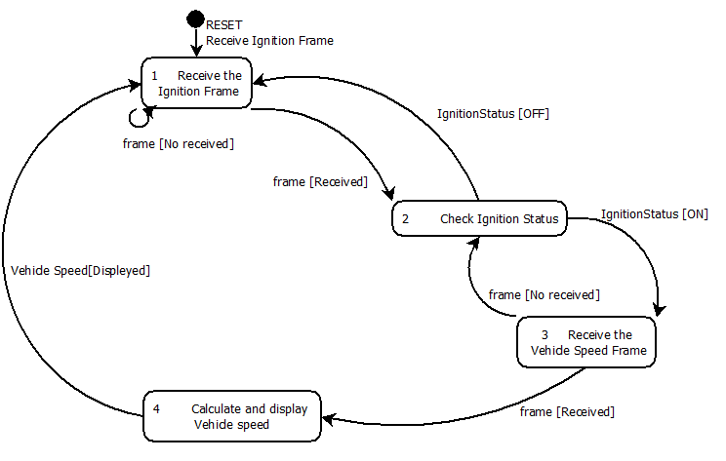
Odometer.

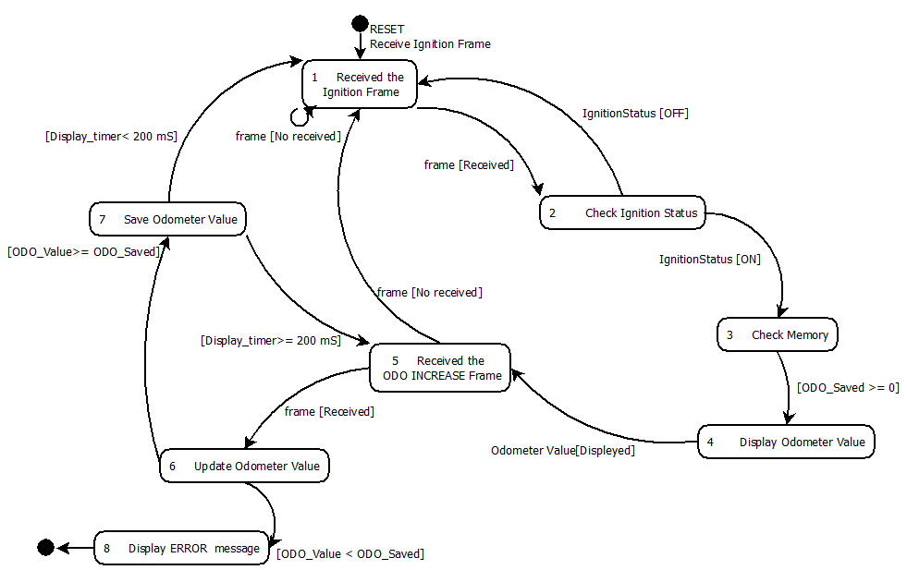

Fuel gauge.

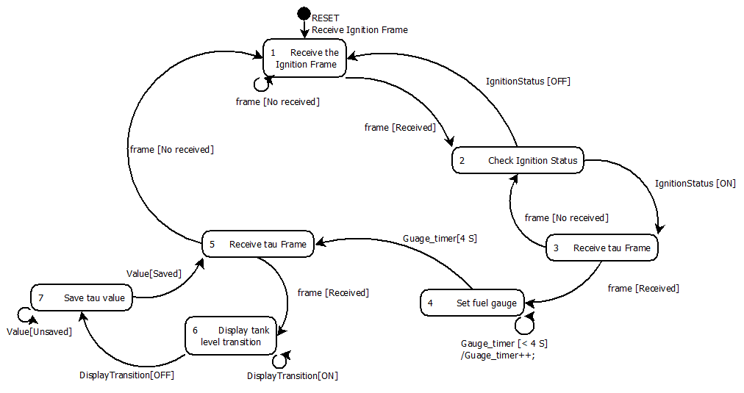

Visual Indicators.

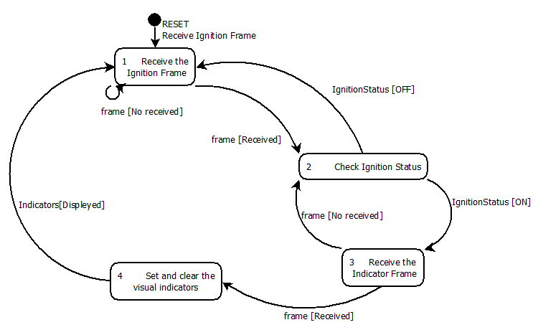

SW Component internal breakdown
For complex SW Components, the designer may define SW Subcomponents. Please consider also the work step "Deal with complexity" provided by the method for Detailed SW Design.
Note: SW Subcomponents are synonymous with the previous used term "Module"
Mapping to the file structure:
- Non complex SW Components should be represented by one object file.
- For complex SW Components each SW Subcomponent should be represented by one object file.
<Subcomponent decomposition if applicable>

Functional Decomposition
Overview of functions and their dependencies shown by a Static Function Tree
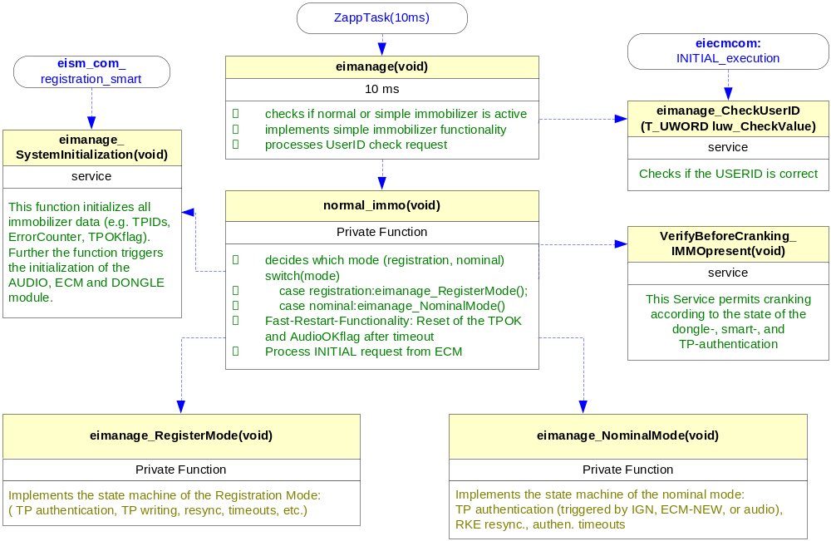
Function Description and Dynamic Behavior
Provide detailed static and dynamic description of all functions of the SW Component.
Functions which are defined in other SW Components shall only be referenced in the external interface description!
The signature description shall be done inside the function header in the source code.
For each function, the following section should be copied

Function <Type> <function name> (type par 1, .., type par n)

Description | Brief description of the function behavior and useful remarks
Parameter 1  <input| output| inout> | Give an explanation if the parameter shall be checked by the user, or if a check is implemented in the function here
Parameter 2..n
Return Value
Precondition | e.g. Function can only be called in a certain state, SW component is initialized  Relation between input parameters where applicable (Input for Module Test)
Post condition | e.g. specific State change e.g. car is locked, EEPROM Values written,  Relation between output parameters where applicable
Error Conditions

Dynamic Behavior
State Chart¹, Flow Chart¹
¹ Preferred
In this document, the dynamic behavior shall be designed on an abstract level showing the principle workflow of a function. Do not show the detailed implementation to ensure that the design description can be maintained with a reasonable effort. The target is not to show the complete detailed implementation 1:1.
The detailed design shall reflect in detail what a function is doing from a black box view. The internal details are useful on an abstract, but not very detailed level.
If the function is not complex a short textual description might be sufficient and a graphical description is not needed.
Symbol and function names shall be self explaining.
The link to the implementation may be provided by using the same names as in the design or by a comment showing the full name followed by the declaration showing the implementation.

Function <Type> <function name> (type par 1, .., type par n)
Description | Brief description of the function behavior and useful remarks
Parameter 1
<input| output| inout>
Parameter 2..n
Return Value
Precondition | e.g. Function can only be called in a certain state, SW component is initialized  Relation between input parameters where applicable (Input for Module Test)
Post condition | e.g. specific State change e.g. car is locked, EEPROM Values written,  Relation between output parameters where applicable
Error Conditions

Dynamic Behavior
State Chart¹, Flow Chart¹, Nassi Shneiderman
¹ Preferred
In this document, the dynamic behavior shall be designed on an abstract level showing the principle workflow of a function. Do not show the detailed implementation to ensure that the design description can be maintained with a reasonable effort. The target is not to show the complete detailed implementation 1:1.
The detailed design shall reflect in detail what a function is doing from a black box view. The internal details are useful on an abstract, but not on a very detailed level.
Symbol and function names shall be self explanatory.
The link to the implementation may be provided by using the same name as in the design or by a comment showing the full name followed by the declaration showing the implementation.

